An
INTERNSHIP REPORT
on
DATA ANALYTICS WITH TABLEAU
Submitted in partial fulfillment of the requirements for the award of the degree of
BACHELOR OF TECHNOLOGY
IN
COMPUTER SCIENCE AND ENGINEERING
by
CHEMIKALA LASYA
(Roll No. 22AK1A0567)

Under the Mentorship of
Ms. V Bhargavi, M.Tech
Assistant Professor, CSE Department



DEPARTMENT OF COMPUTER SCIENCE AND ENGINEERING

ANNAMACHARYA INSTITUTE OF TECHNOLOGY AND SCIENCES,
TIRUPATI
(AUTONOMOUS)

Approved by AICTE, New Delhi & Permanent Affiliation to JNTUA, Anantapuramu.
Five B .Tech Programmes (CSE, ECE, EEE, CE, ME) are accredited by NBA, New Delhi.
Accredited by NAAC with 'A' Grade, Bangalore. Accredited by Institution of Engineers (India)KOLKATA.
A-grade awarded by AP Knowledge Mission. Recognized under sections 2(f) & 12(B) of UGC Act 1956.
Venkatapuram (V), Renigunta (M), Tirupati, Tirupati District, Andhra Pradesh -517520.
2025-26

ANNAMACHARYA INSTITUTE OF TECHNOLOGY AND SCIENCES, TIRUPATI
(AUTONOMOUS)
DEPARTMENT OF COMPUTER SCIENCE AND ENGINEERING



CERTIFICATE
This is to certify that Ms. CHEMIKALA LASYA (22AK1A0567) has carried out Virtual Internship on “Data Analytics With Tableau” and submitted to the Department of COMPUTER SCIENCE AND ENGINEERING of Annamacharya Institute of Technology and Sciences, in partial fulfilment of the requirements for the award of the Degree of Bachelor of Technology in Computer Science And Engineering is meeting the Academic Regulations.

Signature of Internship Mentor Signature of HOD

DECLARATION

I am CHEMIKALA LASYA (22AK1A0567), Studying Final year B. Tech in Computer Science And Engineering of Annamacharya Institute of Technology and Sciences, hereby declare that this Internship report titled “DATA ANALYTICS WITH TABLEAU” has been done by me. The Internship work carried out is original and has not been submitted to any other University or Institution for the award of any credits. I promise to meet all the mandatory requirements as specified by the Academic regulations

PLACE:
DATE :

SIGNATURE

ACKNOWLEDGEMENT

The needs and deeds of a particular person are only satisfied with the support and endurance of many.

I would like to express my deepest appreciation for All India Council for Technical Education, AICTE New Delhi for their commitment to the betterment of technical education and the opportunities they have made available to our students. I look forward to the continued collaboration between SMARTBRIDGE and APSCHE to provide more student Internships to gain hands-on experience and become better-prepared professionals.
I would like to extend my heartfelt thanks to Principal Dr. C. Nadhamuni Reddy for his constant encouragement and support during the Internship period.
I would like to express my heartfelt thanks to Dr. T. Sreenivasula Reddy, Professor & HOD, Department of CSE during the progress of Internship for his timely suggestions and help in spite of his busy schedule.
I would like to extend my heartfelt thanks to our department Internship Coordinator Mr. M Kiran Moni, Assistant Professor, Department of CSE for providing consistent support for us to complete the course modules in order to complete my internship.
My heartfelt thanks to Internship mentor Ms. V Bhargavi, Assistant Professor, Department of CSE for her valuable guidance and suggestions in analysis and testing throughout the period, till the end of Internship work completion.
Finally, I would like to express my sincere thanks to faculty members of CSE Department, Lab Technicians, Internship company trainers and friends, one and all that have helped me to complete the Internship successfully.

CHEMIKALA LASYA
Roll No 22AK1A0567

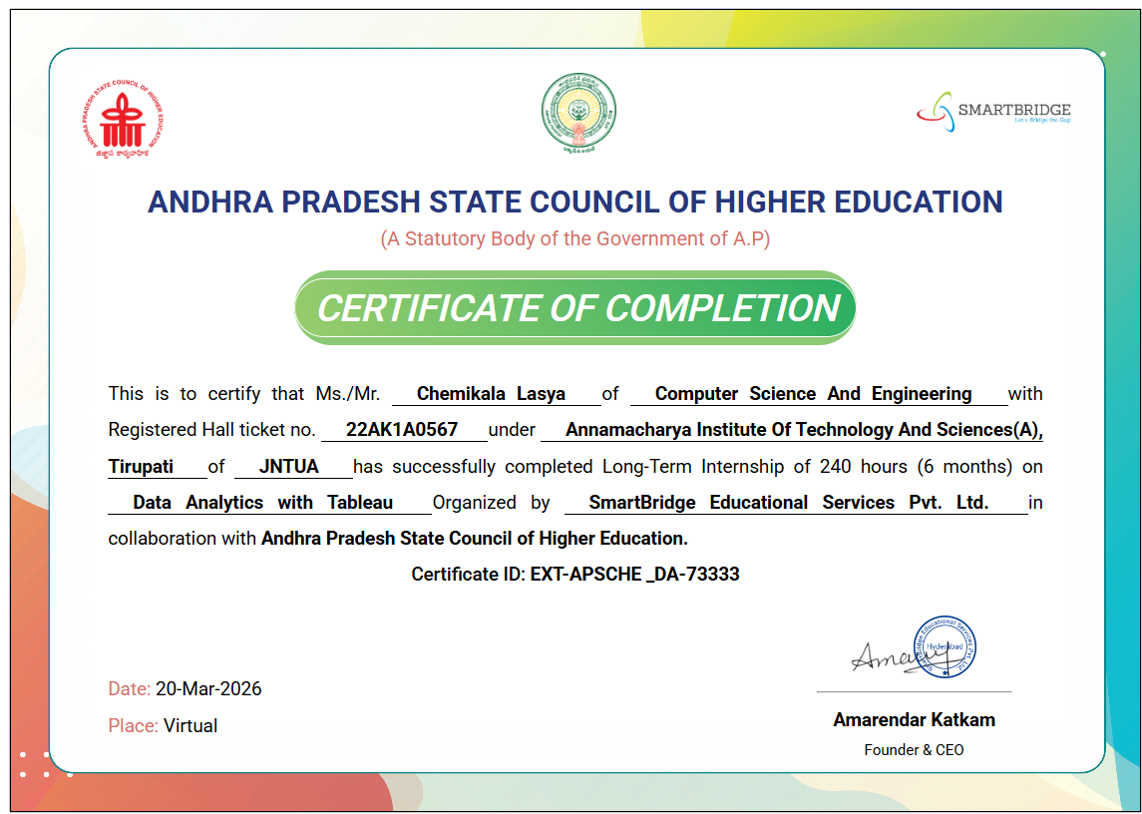

CERTIFICATE

ABSTRACT
This project focuses on analyzing housing market trends using Tableau to understand factors affecting property prices. It uses a dataset with features like location, size, bedrooms, renovation details, and condition. Data preprocessing and visualization techniques are applied to identify patterns and relationships. Multiple worksheets are created to analyze how each feature impacts sale prices. The study shows that location, property size, and bedroom count significantly influence house prices. Renovated and well-maintained houses tend to have higher values. Geographic differences also play a key role in pricing variations. All visualizations are combined into an interactive dashboard with filters. A Tableau Story is used to present insights clearly and effectively. Overall, the project supports data-driven decision-making for buyers, sellers, and investors.

Keywords –Tableau, Data Visualization, Dashboard Design, Data Analytics, Business Intelligence, Interactive Dashboards

CONTENTS
Page No.
1. Chapter 1 ……………………………………………………………………… 1
Introduction
2. Chapter 2 ………………………………………..…………………………… 3
Monthly Overview
3. Chapter 3 ……………………………………….……………………………. 4
Modules
4. Chapter 4 …………………………………….………………………………. 19
Project
5. Chapter 5 …………………………………………………….......................... 28
Result and Conclusions
6. Chapter 6 …………………………………………………….......................... 30
Verifiable Credentials

